Installing QX tool Driver
Win 7 screen shots but will work for either Win 7 or Win XP
- Click on the ”start”/ “Windows” icon in the lower left hand corner of your desktop
- Select Run or type run in the search box.
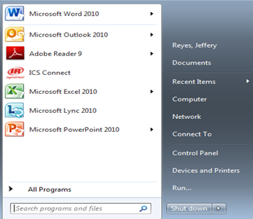
- Type devmgmt.msc into the “open” box on the run screen. Click “ok” and this will open your device manager.
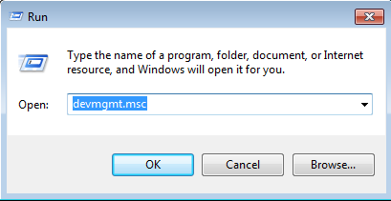
- From the device manager under other devices you want to find “STM32 Virtual COM port”
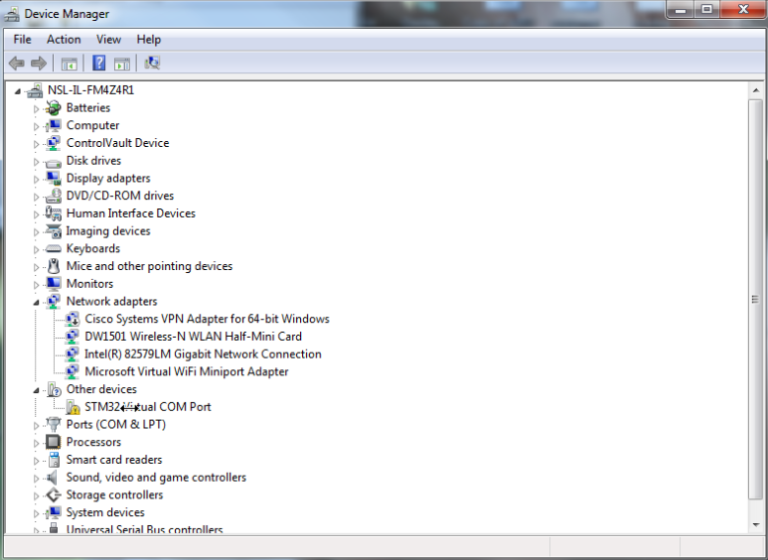

- Right Click on “STM32 Virtual COM port” and select “update driver software”
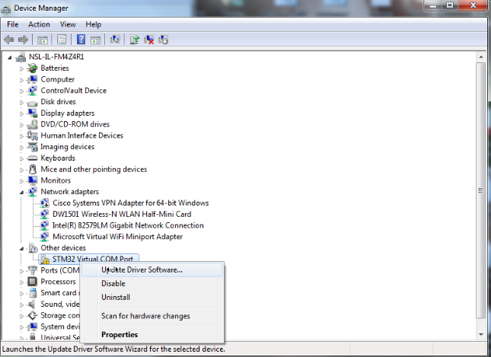

- From here you want to select the “browse my computer for driver software” and locate the thumb drive or location of the tool drivers.
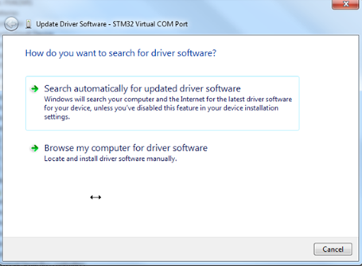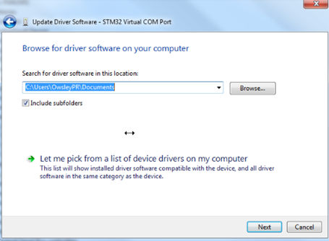

- From C:\Program Files (x86)\Ingersoll Rand\ICS\Firmware select either WIN7_QX tool driver or WINXP_QX tool driver depending on the operating system you are using.
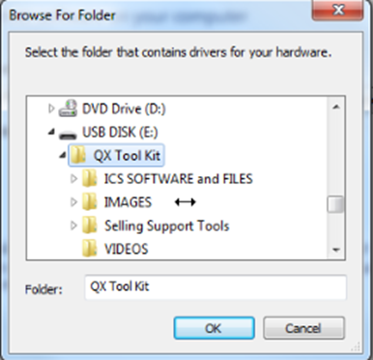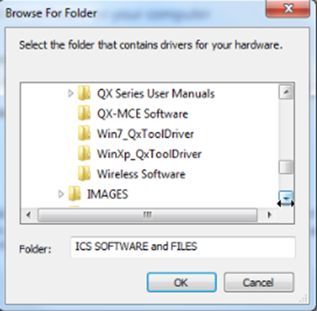
- After selecting the correct driver version follow the rest of the on screen prompts allowing windows to install the driver. This should successfully complete the installation for the Windows QX tool driver.

